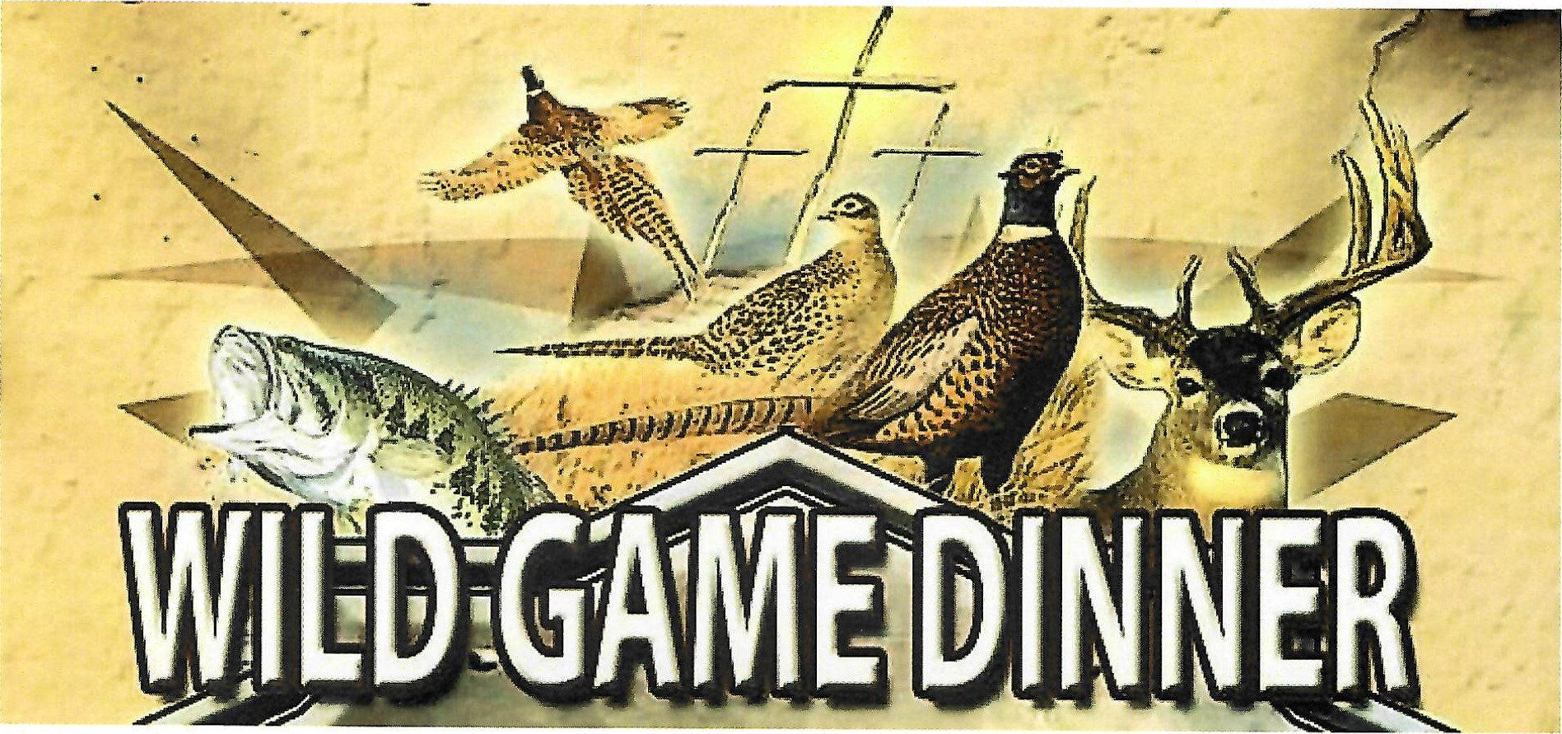
Fairfield County Fish & Game
Where: Anthonys Lake Club, Danbury
When: Saturday, March 23, 2024
Doors open at 5.30pm for Appetizers.
BEER, WINE, SODA DOOR PRIZES - RAFFLES
Tickets: $60.00 (cash or check)
See Kevin Dee for tickets!

